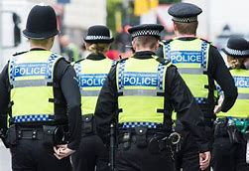

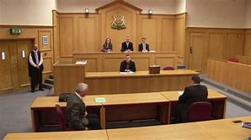
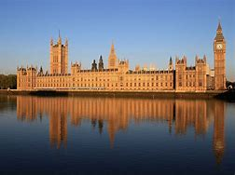


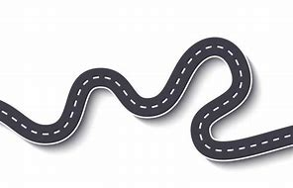
Identity
Role & regulation of the media
International Organisations
Life in Modern Britain
World with no laws
Rule of Law
Legal representatives
Rights & Responsibilities
Development of UK law
Development of law from outside the UK
Rights & responsibilities of the police
Crown Prosecution Service
Judiciary
Juries
Profile of crime in the UK
Crime in the courts
Sentencing
Youth Justice System
Exams - Summer – Year 11
Politics & Participation
Democracy
British constitution
Political parties
The role of Parliament
Electoral systems
Members of Parliament
Formation and role of the government
Start - Autumn - Year 10
Deciding the question or the issue
Carrying out initial research
Taking the action
Planning the action
Active Citizenship
Evaluate the process
Assess the impact of the action
The five British values

