UNIFORM ORDER FORM

At Bishopton we feel that a uniform helps to reduce economic and social barriers between pupils and helps them feel unified, with a greater sense of belonging. We also feel that being smartly dressed helps prepare the pupils for learning.

Bishopton expects all pupils to be in school uniform this consists of:
- Black shoes/trainers with no visible marks or signs*
- Black trousers or skirt
- White Polo shirt or school shirt
- Navy Jumper
*Where pupils’ shoes are not appropriate plimsolls will be offered to the pupil.
- Where pupils clothing does not meet the guidelines issued by school, the pupil will be offered clothing by the school.
- If a pupil refuses to accept uniform offered by the school then a phone call home will be made and the parent/carer will be requested to either, bring suitable uniform to school or to give permission for the pupil to go home, change into suitable uniform and return to school. If the pupil does not return to school this is recorded as an unauthorised absence.
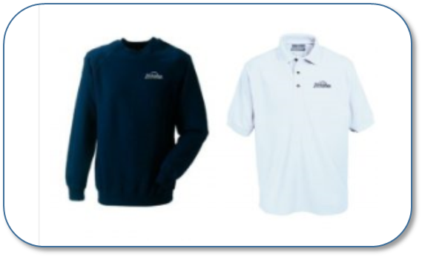

UNIFORM ORDER FORM

School: |  |  | Bishopton  Marsh House Avenue  Billingham  TS23 3HB
Name of pupil:
Name of parent/carer:
Address:
Telephone:
Item | Price | Age |  | Quantity | Cost
BM Polo Shirt  (inc. embroidery) | £7 up to age 13  £9.60 age 14+
7620B Navy Sweatshirt (inc. embroidery) | £12.50
Total Cost:

Please complete this form to order your items and hand it to reception together with the amount payable.

